**GUEST OF THE MONTH/March 2025**

**Jonathan Leung, Director of Water Quality - LADWP**

**POST-WILDFIRE RESTORATION OF DRINKING WATER QUALITY IN THE PALISADES**

**By Robert Yoshimura**

Jonathan Leung began the presentation by handing out copies of the “Do Not Drink” notice that was originally issued on January 10, 2025, to customers in the Pacific Palisades neighborhood of Los Angeles during the devastating wildfire that engulfed the area. The notice further cautions customers to limit the use of hot water including hot showers and baths, to air dry laundry, and not to use the steam dry cycle when using an automatic dishwasher. These precautions aim to reduce the vaporization of volatile organic compounds (VOCs) in the water, which may pose an inhalation hazard.

The notice was required by public health regulations under AB 541, enacted in 2023, based on lessons from previous wildfires that impacted urban areas, including the Paradise and Santa Rosa fires in California. The regulations are enforced by the Division of Drinking Water (DDW) and triggered by wildfire events greater than 300 acres where a structure or structures connected to the public water system has been damaged. In such cases, the water utility is required to test the water for benzene, and if found, the utility is further required to adhere to a restoration protocol that involves multiple steps as follows:

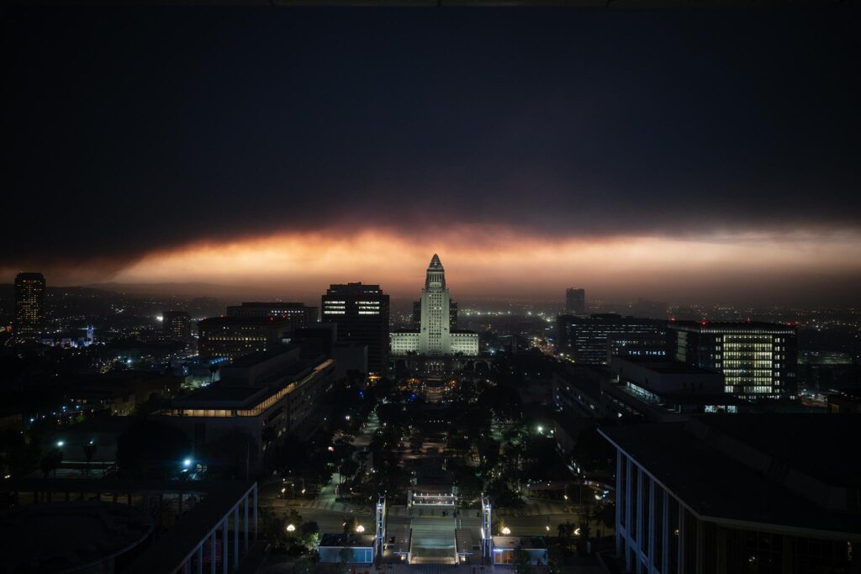

1. Issue notice
2. Restore system pressure
3. Confirm water quality at treatment plant
4. Assess damage and plan
5. Clean out pipes
6. Stagnation and comprehensive water quality testing
7. Obtain lab results
8. Submit results to regulator
9. Lift “Do Not Drink” notice

Benzene is a toxic volatile compound found in plastics that can be released when plastic pipe and other plastic fixtures are melted or otherwise damaged by fire. When such plastics exist in the plumbing of fire-damaged homes, a concurrent loss of system pressure can result in the siphoning of contaminated water from the homes back into the municipal water system. In addition to benzene, LADWP tested for a total of 72 regulated VOCs on each sample collected. A total of more than 470 samples were tested during the course of this event. Challenges associated with the sampling program were the requirement to stagnate the sample in-place for 3 days before collection and testing and the need to fabricate plumbing fixtures to enable water meters to be temporarily replaced by sample taps. The stagnation requirement was intended to determine if benzene was leaching from PVC pipe in the distribution system. However, LADWP does not use PVC pipe anywhere in its distribution system, thus the requirement is moot.

Once the pressure was restored to the distribution system, LADWP began a systematic program of main flushing and testing within the affected area starting at the highest elevations and working downward in the general direction of the flow of water. The water sampling protocol called for additional flushing and testing whenever benzene was detected in a given sample. This protocol resulted in a few instances of repeated flushing and expanded sample testing until all contamination was flushed out. By the end of February, initial water testing of the entire area revealed several positive samples requiring additional work, and that no positives were found in a large area at the east end of the community. Consequently, a partial cancellation of the “Do Not Drink” order was issued on February 27, 2025. On March 7, 2025, the DDW deemed that water quality had been restored and approved the cancellation of the “Do Not Drink” notice for the rest of the Palisades.

To inform the public about this crisis, LADWP developed a comprehensive public notification and outreach plan. Elements of the plan include revised “Do Not Drink” and Cancellation notices; doorhangers for lifted areas; public information on the LADWP,com website; calls, emails, and texts to subscribed customers; Call Center staff briefings; and community meetings. The LADWP website incorporated a unique feature that enables customers to input their addresses and track the status of this water quality restoration effort in their service zones.

The restoration of water quality in less than two months after such a severe wildfire was a significant accomplishment. Lessons learned from this event will be documented and some will be applied to scientific research to answer questions that popped up during this hectic time.